Electrophysiological characteristics of the dorsal, middle and ventral hippocampus in the behaving rat
Jagdish Patel, Sebastien Royer, Caroline Giesler, Gyorgy Buzsaki
Center for Molecular and Behavioral Neuroscience, Newark, NJ 07102
The hippocampus is known to be critical for multiple mnemonic and non-mnemonic functions. However, whether the entire hippocampus or its specialized parts are responsible for these functions is not well understood. Although the fundamental anatomical organization of the hippocampus along its septo-temporal axis appears similar, notable differences in its afferent and efferent connections between the dorsal and ventral hippocampus have been noted. Although lesion studies support dorso-vental functional distinctions, it is not known whether such differences are supported by corresponding physiological properties; largely because most of the physiological studies in rodents have been performed in either the dorsal or posterior hippocampus.
We recorded LFP and unit activity from multiple CA1 and CA3 sites along the septo-temporal axis of the hippocampus, including the ventral tip of the hippocampus, including theta, gamma and sharp wave ripple (SWR) patterns during exploration and immobility/sleep periods. We measured the power correlation at each frequency band at different locations and examined their correlations. Theta oscillations were much less expressed in the ventral hippocampus and peaks at theta frequency were rarely present in the power spectrum, mainly due to the presence of large power in the delta and gamma frequency bands. Nevertheless, gamma power of the ventral hippocampus was phase-modulated by the theta oscillations in the dorsal hippocampus. SWR were also present in the posterior and ventral CA1 regions but their power coherence was limited. Only during large amplitude SWRs did we observe field and unit synchrony along the septo-temporal axis. These preliminary results suggest fundamentally different temporal dynamics in the dorsal and ventral hippocampus.

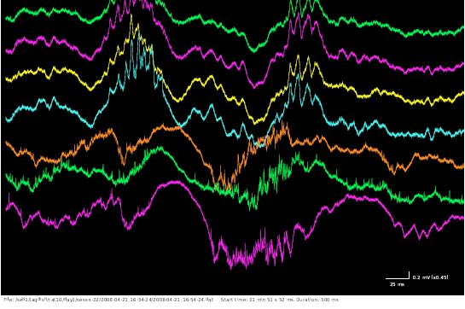

Fig 1: Top 4 traces are from DH CA1 layer while the 5 and 7 from ventral CA1 and green (6) from middle hippocampus.

