Multiple Fluid Injections Cannulas

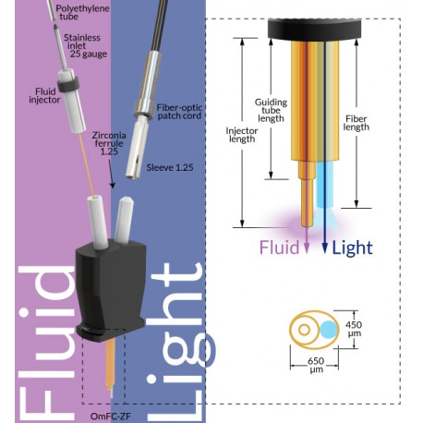

http://doriclenses.com/life-sciences/multiple-fluid-injections/932-multiple-fluid-injections-cannulas.html?search_query=multi&results=33