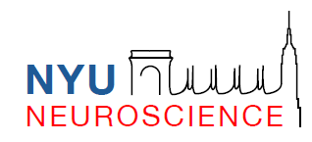

NYU Neuroscience Institute
György Buzsáki, MD, PhD
Biggs Professor of Neuroscience, Physiology and Neurology

Editor
PNAS

February 8, 2021

Dear Editor:

Enclosed please find our re-revised manuscript “(Cholinergic suppression of hippocampal sharp wave ripples impairs working memory), which we resubmit with the final requested changes.

We look forward to your decision in due course.

Sincerely yours,

Gyorgy Buzsaki, M.D., Ph.D.

